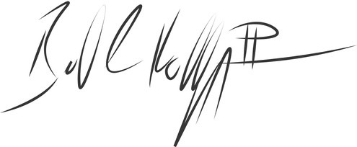
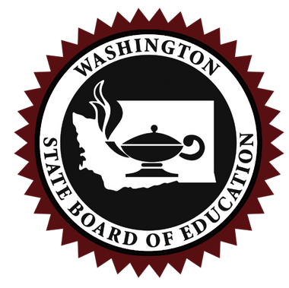
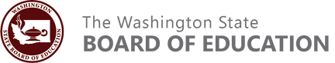
S
Washington State Board of Education Certificate of Private School Approval 2024-2025
Havenwood Learning Sanctuary
Auburn, Washington
Based upon a review of the information submitted in the private school approval application, the school named above is recognized as having met all conditions specified in Chapter 28A.195 RCW and Chapter 180-90 WAC.
Signed this 5th day of December
Bill Kallappa II, Chair State Board of Education
S
Washington State Board of Education Certificate of Private School Approval 2024-2025
Risalah School of Excellence
Kirkland, Washington
Based upon a review of the information submitted in the private school approval application, the school named above is recognized as having met all conditions specified in Chapter 28A.195 RCW and Chapter 180-90 WAC.
Signed this 5th day of December
Bill Kallappa II, Chair State Board of Education

