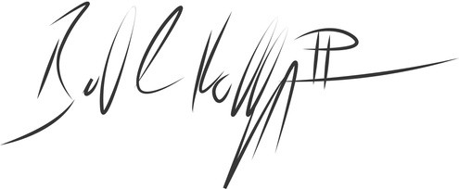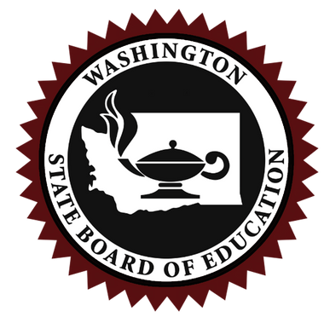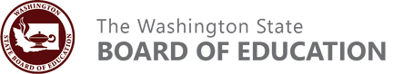

S

Washington State Board of Education Certificate of Private School Approval 2024-2025

Enlightium Academy

Spokane, Washington

Based upon a review of the information submitted in the private school approval application, the school named above is recognized as having met all conditions specified in Chapter 28A.195 RCW and Chapter 180-90 WAC.

Signed this 16th day of October 2024

Bill Kallappa II, Chair State Board of Education



S

Washington State Board of Education Certificate of Private School Approval 2024-2025

Mannahouse Christian Academy

Vancouver, Washington

Based upon a review of the information submitted in the private school approval application, the school named above is recognized as having met all conditions specified in Chapter 28A.195 RCW and Chapter 180-90 WAC.

Signed this 16th day of October 2024

Bill Kallappa II, Chair State Board of Education



S

Washington State Board of Education Certificate of Private School Approval 2024-2025

Evergreen Christian Private School

Federal Way, Washington

Based upon a review of the information submitted in the private school approval application, the school named above is recognized as having met all conditions specified in Chapter 28A.195 RCW and Chapter 180-90 WAC.

Signed this 16th day of October 2024

Bill Kallappa II, Chair State Board of Education



S

Washington State Board of Education Certificate of Private School Approval 2024-2025

Motion Christian Schoool

Puyallup, Washington

Based upon a review of the information submitted in the private school approval application, the school named above is recognized as having met all conditions specified in Chapter 28A.195 RCW and Chapter 180-90 WAC.

Signed this 16th day of October 2024

Bill Kallappa II, Chair State Board of Education