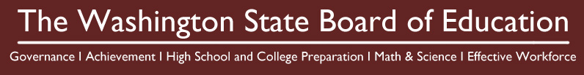
Old Capitol Building, Room 253
P.O. Box 47206
600 Washington St. SE
Olympia, Washington 98504

July 11, 2013

TO: Members of the Achievement and Accountability Workgroup

FROM: State Board of Education

RE: Input on the Accountability Framework—August

The State Board of Education (SBE) appreciates your ongoing willingness to devote your time and expertise to the Achievement and Accountability Workgroup. Your feedback has been instrumental in moving toward a revised Achievement Index. At the August meeting we will share an update of what the State Board has decided thus far, based largely on your input and discussion.

The August meeting marks the beginning of the work on Phase II of the AAW. For the remaining AAW meetings, the SBE will be seeking your feedback on the statewide accountability framework. During the August meeting of the AAW, we ask that you provide input on the following list of specific questions. SBE staff will generate a feedback report to reflect your input on these questions, which we intend to consider in next steps of developing a statewide accountability framework.

Focusing questions for August AAW meeting:
- What should ESSB 5491 indicator goals be based on – how would you approach establishing a goal?
- How should the type and scale of support for districts in the 5329 accountability system vary with school designations?
- How should the Board operationally define “recent and significant progress” as exit criteria for Required Action?
- How should the accountability framework address the transition to the Common Core State Standards?
Meeting materials will provide background information on these questions.

