The Office of Superintendent of Public Instruction (OSPI) is the fiscal agent for the State Board of Education (SBE). The SBE agency operates under OSPI rules and policies regarding travel.

Travel to Board Meetings
All members must reside/work more than 50 miles away from the board meeting location to qualify for lodging. SBE establishes direct bill relationships for lodging, airfare and car rentals for SBE board meetings, therefore; the Executive Assistant must make those travel arrangements. SBE will not reimburse for reservations made by members. Although members have a choice in their mode of transportation to/from a board meeting, OSPI’s fiscal policy is to reimburse travel at the option most cost effective to the state. Reimbursement claims will be adjusted by staff to reflect this policy. Please consult with the Executive Assistant before travel if you’d like advisement on which travel mode is most cost effective.

Board Travel Expenses Eligible for Reimbursement (receipts required unless otherwise noted)
- Meals not provided at meetings are reimbursed at state per diem rates based on the county of the meeting. No receipts required.
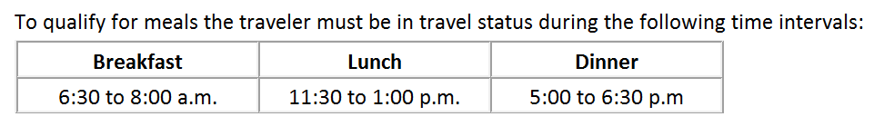
- Mileage (receipts not required)
- Self-parking
- Tolls
- Taxi fares (when a rental car isn’t available or a taxi is most cost effective)
- Gas for rental cars (please see note below)
- Airport luggage fees
- Shuttles
- Coach train tickets (if cost is less than airfare)
- Ferry fares
Enterprise Rental Cars
Enterprise Rent-A-Car is the contracted vendor for reserving rental cars and are paid on direct-bill. Members are responsible for filling up rentals cars before returning them. Enterprise Rent-A-Car may charge SBE $7-8 per gallon to fill the car up if it’s not returned with a full tank. If a member fails to fill up the rental car, it may result in the gasoline charges deducted from their reimbursement claim.

Airport Parking
Per the OSPI travel policy, the maximum a board member can receive for airport parking reimbursement is $21 per day. Reimbursement without receipt for any expenses which do not provide a receipt we can authorize up to $40 reimbursement.
Note for Western Region Board Members: You are eligible to receive a 30 percent discount on standard parking rates at Wally’s Parking Garage in Seattle. Please provide the cashier your SBE business card upon checkout to receive the corporate discount.
Items not Eligible for Reimbursement
- Valet parking services (unless the hotel only offers valet and has no regular self-parking)
- Entertainment expenses such as radio, television or other items of a similar nature
- Any upgrades you’ve requested for lodging, trains or rental cars (this includes GPS)
- Personal telephone calls and out of pocket charges, such as if you locked your keys in the car
- Tips or gratuity
- Alcohol expense
- Meals paid for another individual, including other members and student board members
Coupling Board Meetings With Other Events:
If coupling vacation time, business trips or other events with a SBE board meeting, the SBE will only reimburse costs related to the board meeting. Reimbursement will be granted at the amount it would cost as if the member was traveling to/from their primary residence. Please contact the Executive Assistant if your travel to a board meeting will be in conjunction with other plans.

Traveling with Family, Friends and Pets:
If a spouse and/or family members will be traveling with you to a board meeting, the SBE will only pay costs at single occupancy. Reimbursement will be granted at the amount it would costs as if the member was traveling alone to/from their primary residence. Spouses, family members, pets and guests are restricted from the following:
- Riding in any rental transportation that is paid using state funds per the Department of Enterprise Services Transportation Policy 12.30.20a. This includes Enterprise vehicles, charter buses, airport shuttles, etc.
- Eating meals that are provided at a meeting or social and are direct-billed to SBE.

Exceptions to Travel Policy:
If emergencies or circumstances arise where staff cannot be reached during non-business hours and making/changing your travel plans are necessary, please contact the Executive Assistant the next business day so action can be taken to request an exception.
Members that reside and/or work less than 50 miles from the meeting location could qualify for lodging if any of the following conditions are present:
- An overnight stay in a commercial lodging facility to avoid having a traveler drive back and forth for back-to-back late night/early morning official state business.
- When health and safety of the traveler is a concern.
- When it is less expensive overall for the traveler to stay overnight vs. mileage back-and-forth.
Please contact the Executive Assistant if you feel these conditions apply to your situation.
In addition, a board member’s eligibility for lodging may be determined based solely on their primary residential address and not their work address if the following are present:
- The board member uses annual leave benefits from their employer or leave without pay while in travel status to attend a SBE board meeting.
- The board member does not perform any work duties for their employer during the entire period of travel status to attend a SBE board meeting.

For questions, please contact
Tami Jensen, Executive Assistant
360-725-6027
tami.jensen@k12.wa.us

